Website updates:
- Change header and footer background color to black on all pages

where-you-stand.html
- Tile 5 needs to be the same size as all the other tiles
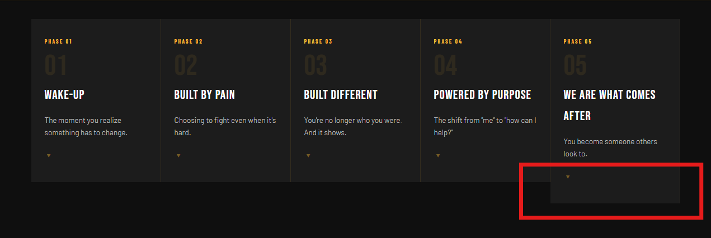

get-started.html
- Indent needs to be fixed


get-involved.html
- Share your story form and contacts us from submissions need to be routed to jasmine@iamredemption.org

